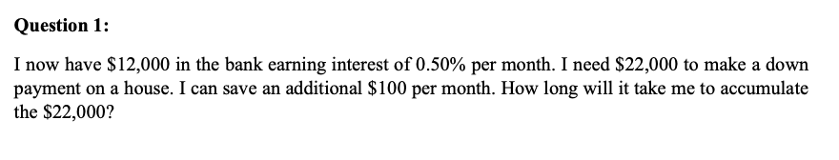
A = P(1 + r/n)^{nt}
$22000 = $12000 + $12000(1 + 0.5/100)^{(100t)}
22000 = $12000 + 12000(1.005)^{100t}
22000 = $12000 + 12060^{100t}
log 22000 = log 12060^{100t} + log 12000
log 22000 = 100t log 12060 + log 12000
log 22000 * log 12060 = 100t + log 12000 * log 12060
100t = log 12000 * log 12060 - log 22000 * log 12060
1/t = 4.081 – 4.079 = 0.02
0.02t = 1
t = 50 months

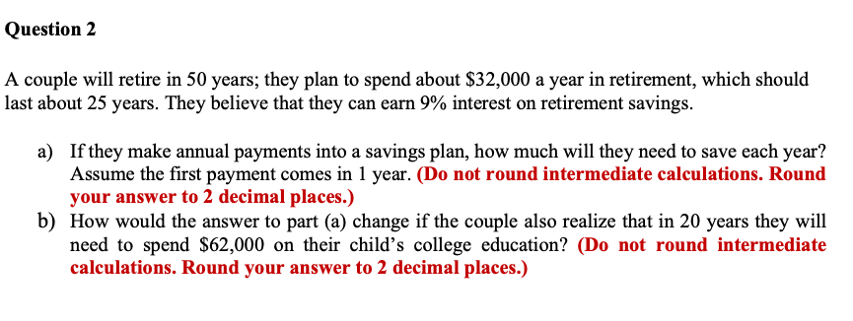

(a) A($32000*25yr(300mnth) = P(x)(1+0.09)^{50yr(600mnth)}
800000 = P(1.09)⁵⁰
log 800000 = 50 log 1.09P
5.9031 =50 log P + 50*0.0374
5.9031 = 50 log P + 1.87
5.9031 – 1.87 = 50 log P
4.0331 = 50 log P
log P = 0.080662
P = 4.60517base100000
P = $460,517
pm; P = $460,517/600
pm; P = $767.52
(b)
= A($32000*25yr ) = P(1+0.09)^{20yr} + (p1.09^{20yr} - $62000)(1.09^{30yr})
800000 = P1.09²⁰ + (p1.09^{20yr} – 62000)(13.2677)
800000 = P1.09²⁰ + 13.2677p1.09²⁰ – 822597.4
800000 – 822597.4 = -22597.4 = P1.09²⁰ + 13.2677P1.09²⁰
log(-22597.4) = 20log 1.09P + Plog265.354
4.3541 = 0.74853P + 2.4241P
4.3541 = 3.17263P
Pbase100000 = 137239/20yr
pm; P = $571.831

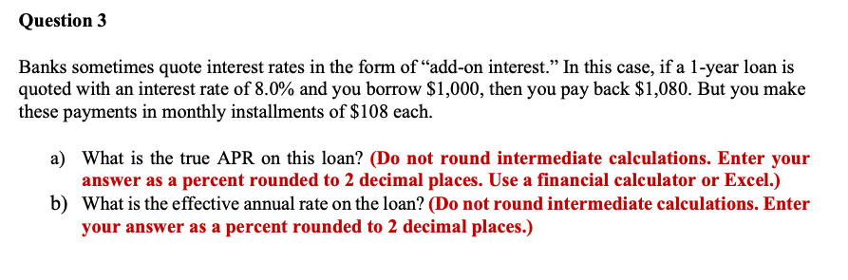

(a) APR = ((fees+interest/principal/n) * 365) * 100
APR = 0.08/1000/30 *365 *100
APR = 0.09733
APR = 9.733%
(b) R = (1 + i/n)^{n} – 1
R = (1 + 0.08/0.09733)^{0.09733} -1
R = (1 + 0.8219)^{0.09733} – 1
R = 1.0601 – 1
R = 0.0601
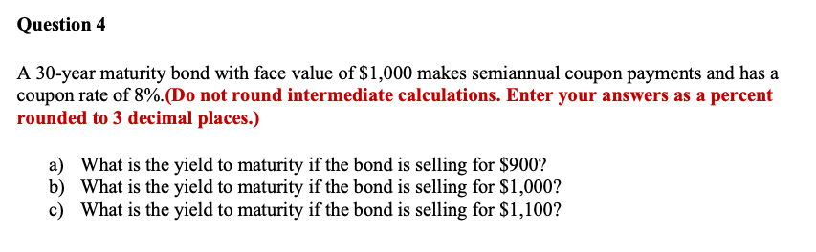
Qn 4
- YTM = √facevalue/ current price – 1
YTM = √1000/900 -1
= 1.054
- YTM = √1000/1000 – 1
= 0
- YTM = √1000/1100 – 1
= -0.091

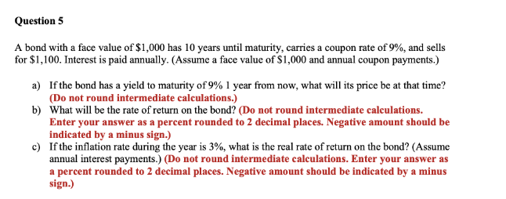

(a) YTM (C + (F-P/1))/(F+P/2)
= (90 + (1000-1100/1))/(1000+1100/2)
= (90 + -100)/1050
= -10/1050
= - 0.00952
=(1-0.00952)(1000)
= $990.48
(b) rate of return
= current value – original value/original value * 100
= 990.48-1000/1000*100
= -95.20/100 / -4.8%
(c) inflation adjusted return
= 1+return/1+inflation rate – 1
= 1+-0.048/1+0.03 – 1
= 0.92427 – 1
= -0.08%
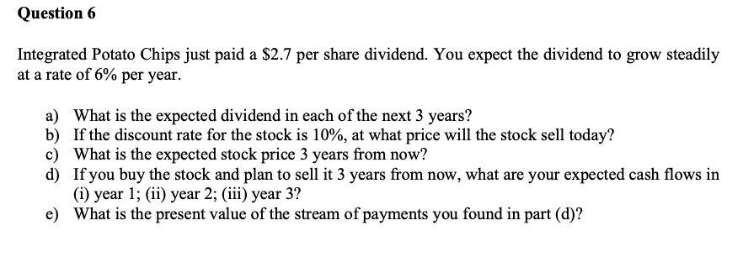
Qn 6
(a) year 1
P = D₁/(r-g)¹
P = 2.7/1-0.06
P = 2.7/0.94
P = $2.872
year 2
P = 2.7/(1-0.06)²
P = 2.7/0.8836
P = $3.056
year 3
P = 2.7/(1 – 0.06)³
P = 2.7/0.8306
P = $3.251
(b) value of stock = expected dividend per share/ cost of capital equity – dividend growth rate
= 2.7/0.1-0.06
= 2.7/0.04
= $67.5
(c) value of stock = expected dividend/ growth rate
= $3.251/0.06
= $54.18
(d) year 1 cash flows; d = $2.872
year 2 cash flows; d = $3.056
year 3 cash flows = d(3.251) + share value
; share value year 3 = $54.18
year 3 cash flows = $54.18 + $3.251 = $57.431
(e) present value
year 1 = PV = CF/(1 + r)^{t}
year 1 = 2.872/(1 + 0.1)¹ = 2.872/1.1
= $2.611
year 2
year 2 = 3.056/(1 + 0.1)²
= $2.526
year 3
= PV(share value + dividend) = PV($54.18 + $3.251) = PV = 57.431
= PV = 57.431/(1 +0.1)³ = 57.431/1.331
= $43.149

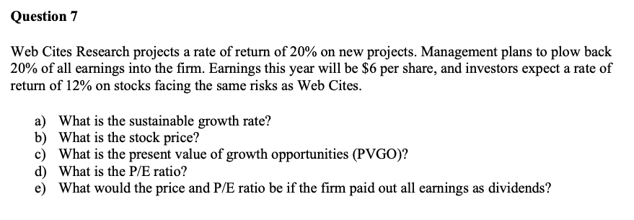

(a) Retention ratio * return on equity
0.2 *0.2
= 0.04
(b)
P = D₁/r-g
= 6/0.12-0.04
= 6/0.08
= $75
(c)
PV = $75/(1+0.2)¹
= $62.5
(d)
= share price/earnings per share
= 75/6
=12.5
(e)
market value per share/earnings per share
price- market value per share
=75/62.5
= 1.2

